12 mm Handscraped Laminate
DETAILED HANDSCRAPED WOOD VISUAL FLOORING

- 12 MM thick x 6.5” wide
- 2G Valinge Click locking system on HDF
- Visuals offered in several species
- Four sided pressed bevel
- All products are hand scraped
- See Rustic Life collection for additional scraped visuals
- AC3 wear layer – heavy residential
- Warranty: 25 years
- Board length: 48 inches
- Packaging - 17.12sf/ctn, 60ctn/plt, 1027.20sf/plt, 16plt/cont, 16,435.2sf/cont (20')
  - Pallet weight – 2390 lbs.

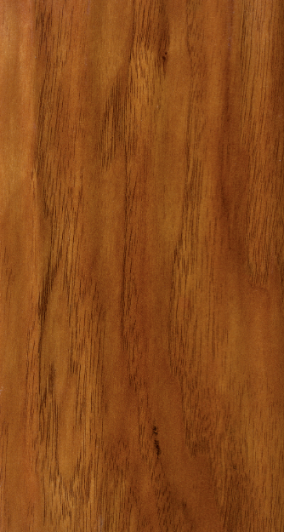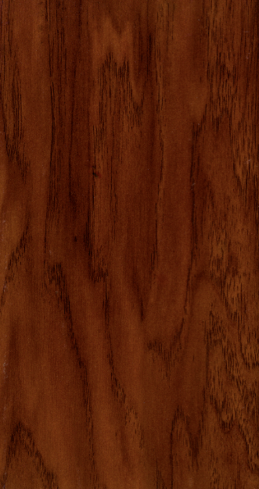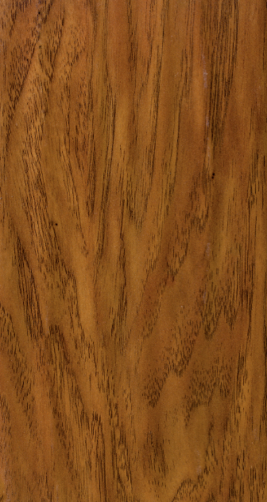
Almond
Batula
Cypress

